|  |  |  |
| --- | --- | --- |
|  |  |  |
|  |  |

**A s eri e s of two w orks h op s pre se n te d by Lorrain e S an ds, Edu catio n al Le ade rsh ip Pro j ect Ltd**

# Pa rt O ne: Sa turda y 24th February 2018 9:00a m – 3:00p m

**Eastbay REAP, 21 Pyne St, Whakatane**



## M or e t ha n j us t an E ar l y

**Ch i l dh o o d Cu r r ic u l u m. Te**

**Wh ār i ki in th e 2 1 st c e n tu r y.**

These workshops are an opportunity to revisit the principles of Te Whāriki and consider how teachers keep these principles at the heart of their work. We will discuss how these principles are made visible through documentation and the learning environment.

Please bring a copy of Te Whāriki.

Lorraine Sands, Professional Learning Facilitator, Educational Leadership Project Ltd

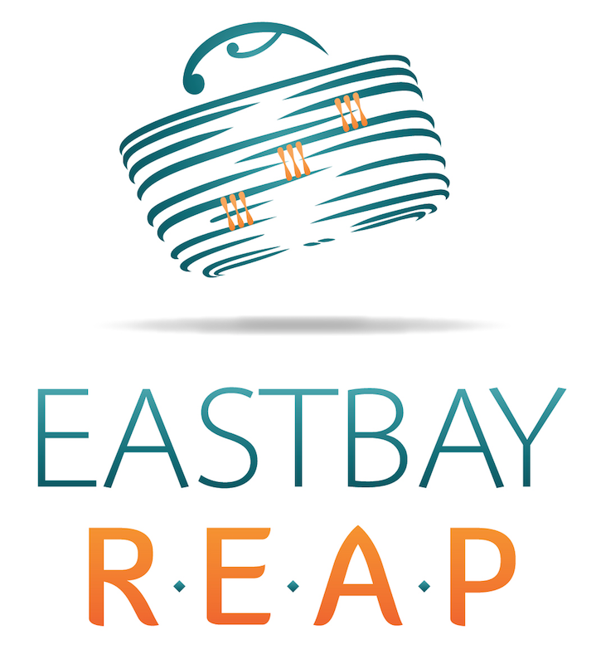

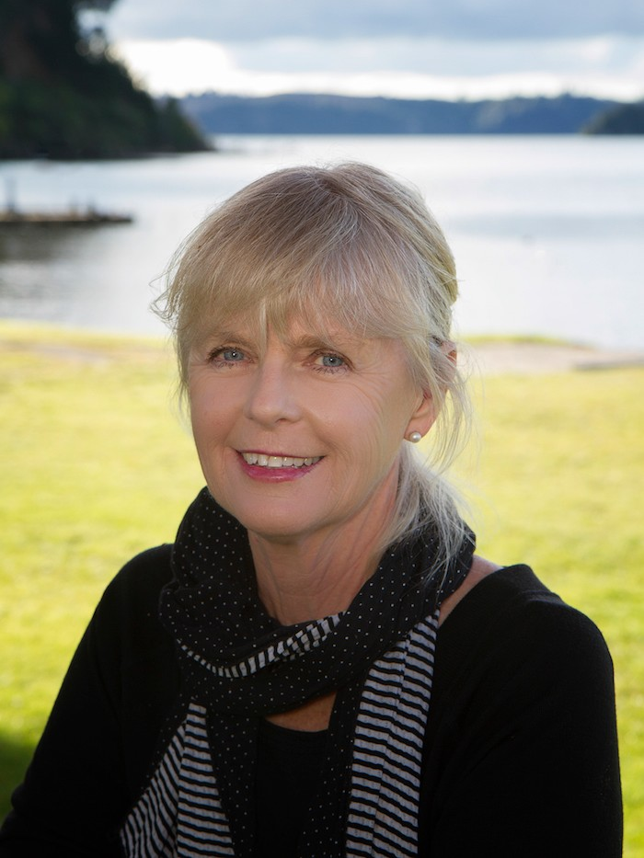

**COST: $75 per person**

 **DATE FOR PART TWO TBC**

Contact: Sheryl Semmens

Email:sheryl@eastbayreap.org.nz

Phone: 07 308 4098 ext 205